Name : Rishi Jain

Roll No. : 22IT3038

GVC LAB 7

Q1:

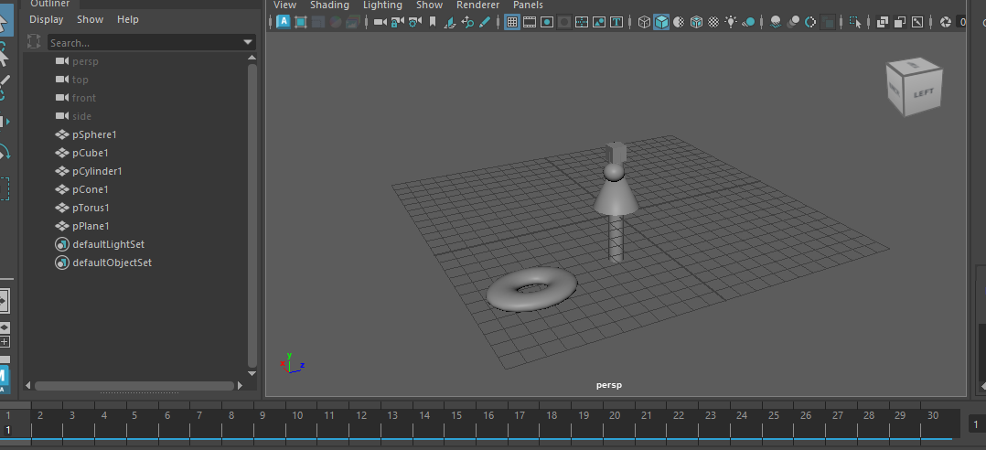

Frame 1

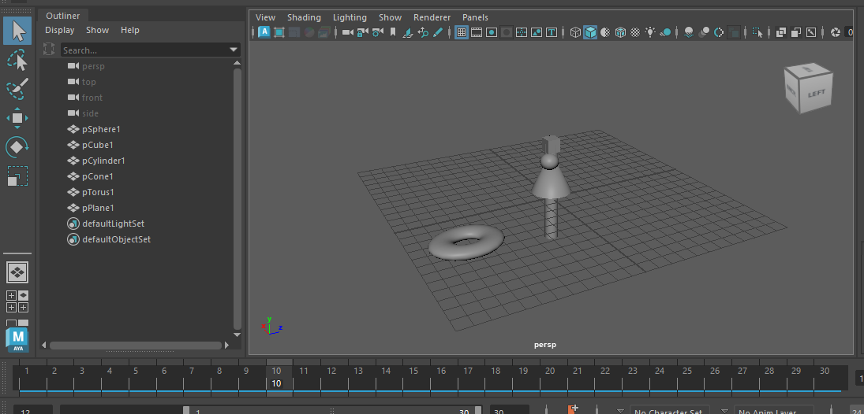

Frame 10

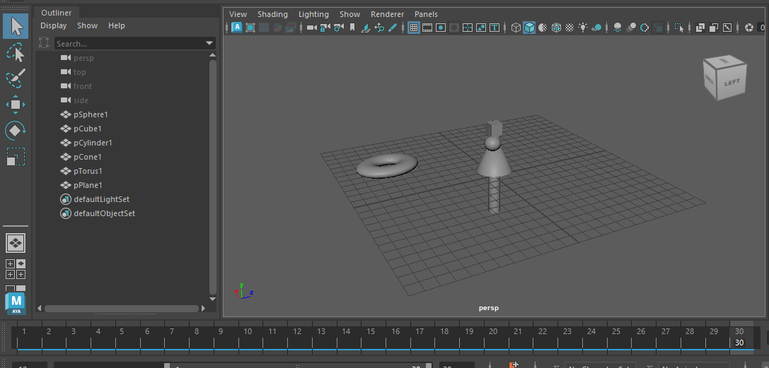

Frame 30

Q2:

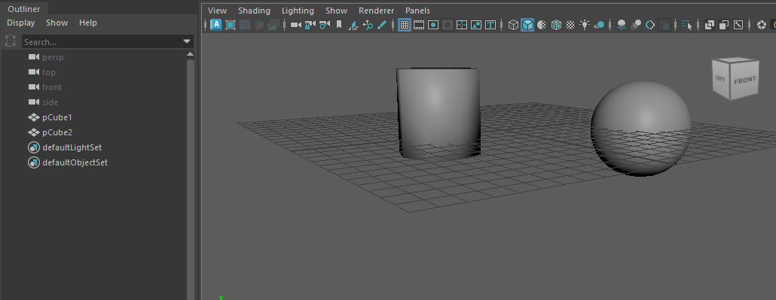

Cylinder and Sphere from Cube object

Q3:

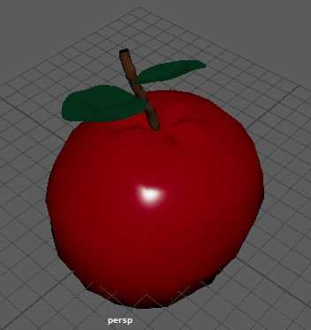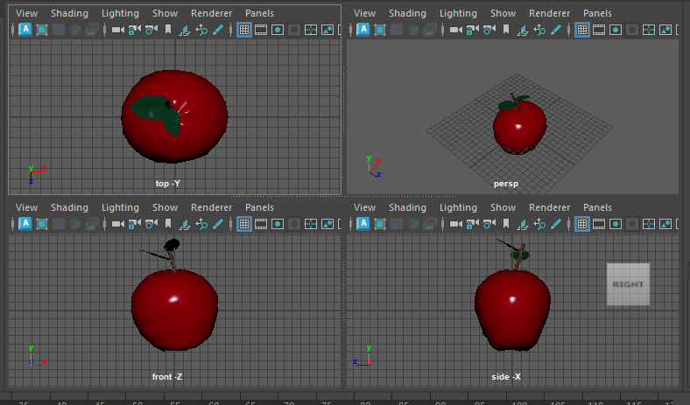

3D model of an apple in maya using primitive modelling in Maya